**ASB db specifications**

**(Correct as at 31/03/2016)**

**By Alan Thompson**

**Technology and locations**

1. Front-end: MS Access 2003

(do not upgrade to 2010 etc, no need as should be developed easily in ASP.net/MVC/C# or other system from ICT).

1. Front-end Location: K:\ASB_Database\ASB Database

(K being the Common drive, no need to change the name or add the version simply copy over this one)

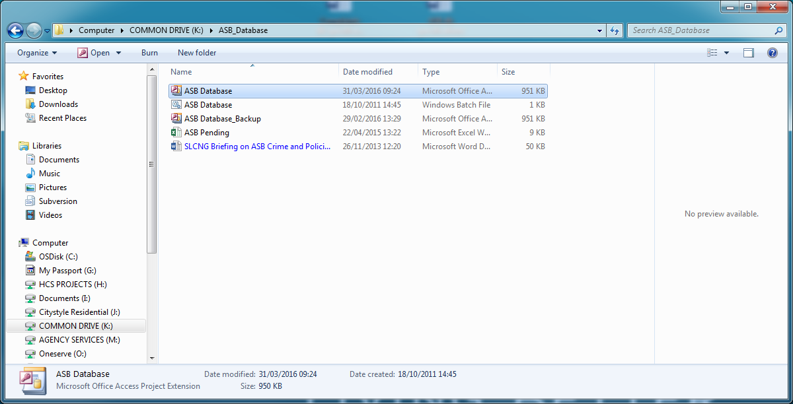

1. Back-end: Sql Server > ohg2k5sql01 > mark > asb% prefixed tables, views etc.

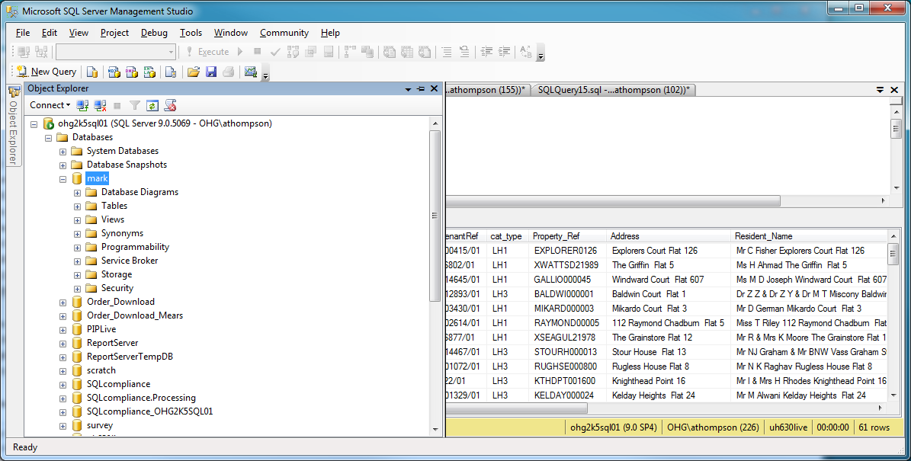

Main tables you need are:

3.1) asbCase – this is the main ‘single’ record for an asb case and is continuous throughout the management of the asb complaint.

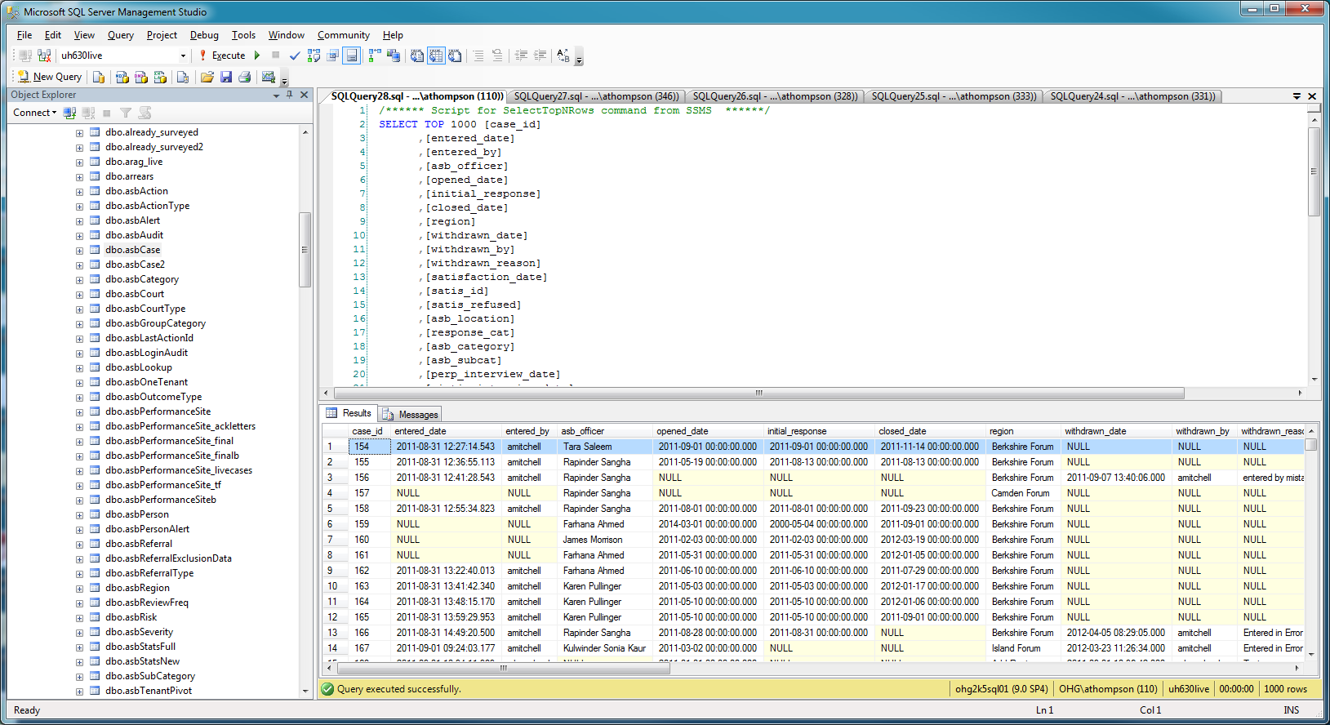

3.2) asbAction – the main ASB actions taken table. Utilised extensively by the team to add case reviews, letters, visits and other important details.

3.3) asbPerson – Note this is NOT the user who is an OH AD granted user to open and use the db. It is the ‘Person’ who is relevant to the case, so Perpetrator, Victim and Other party – such as police.

Please note the uh_ref is relational to UH, why are there NULLs? This is because the person_id is filled and this is a non UH person, ie Police, or some agency of some kind. This is an important fact.

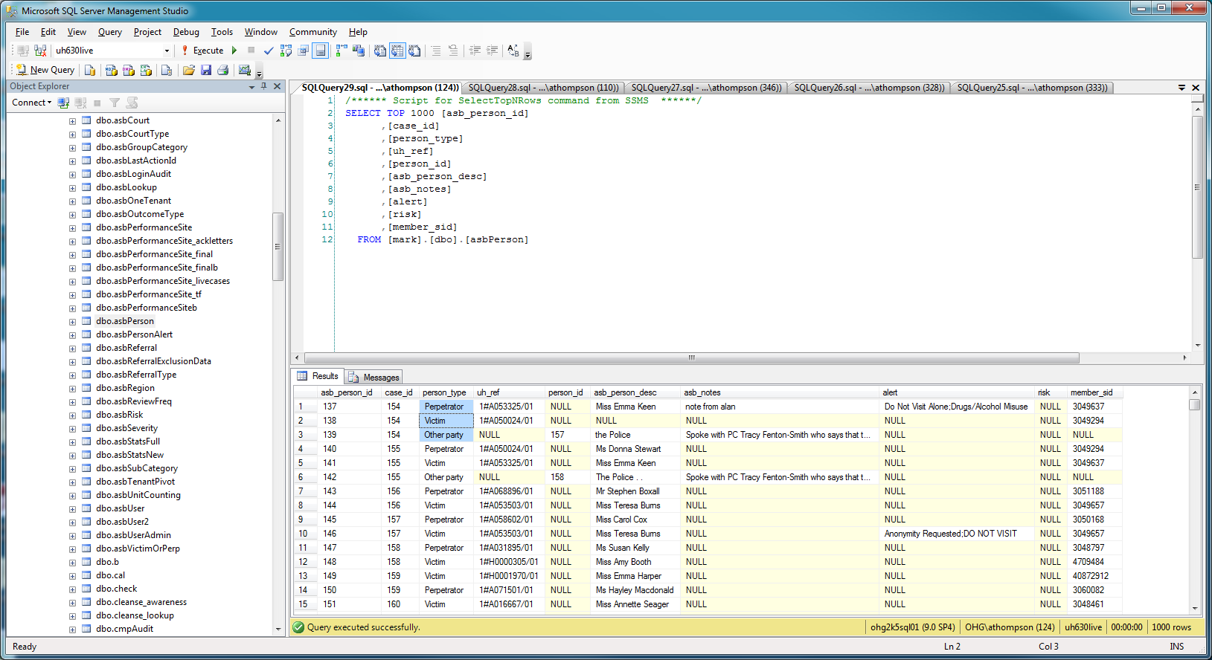

**You should note** this sql back-end is quite badly designed in the sense of normal form. It is not in 3NF (3rd Normal Form) and is quite denormalized really. There are also some hard coded lookups in the access db itself, which when found have been replaced with sql controlling tables. However, not done fully due to the fact this was only a temporary solution. For example we should not see ‘Perpetrator’ in the person_type field shown above. In 3NF, this should be a 1, 2, 3 etc.

1. New development work on the access database or amendments, fixes and admin changes.

To develop, copy the db below to your local machine and make changes. Tip – you may find you open the db and it says ‘read only’ whereby you could not amend the vba/forms etc. However, if you make another copy of this file on your pc, the 2nd copy will allow write access to make your changes.

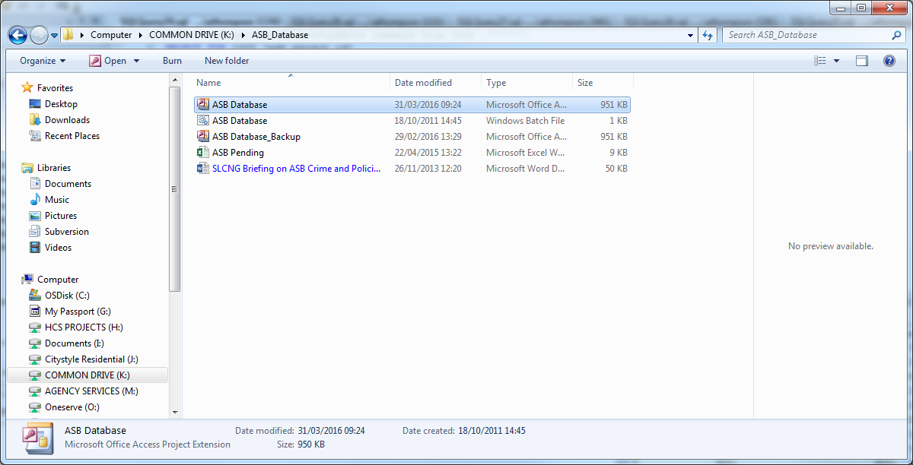

NB: you should ignore all the other files here unless stated. That is for the team alone. You should however, ensure that there are not multiple versions of the db on this drive. The ASB db in particular is prone to having multiple non-actual version here. So a tidy up every 6 months should remove the non-actual one.

1. Script: VBA

To develop the VBA – on the local copy,

Updating the live access db: Copy across and overwrite the file on the corporate drive, inform the ASB team and ask them to get out of the db, or it will NOT copy across anyway.

Note: the VBA is pretty straight forward – if you can do VBA so this specification is NOT going into any tutorial on updating or amending current VBA. It is however a fact that any sql insertion of form data via this front-end of access – will require a fair bit of VBA to be replicated for the new aspect.

**ENSURE** you take a backup of the live one just in case before you overwrite, or if you have made changes that affect the live system, you will need to replace your defect copy with the original, then redevelop to fix improper changes.

1. Letter templates

I have never worked on these and they are not stored in relation to the ASB db itself, however, there are some templates somewhere, but as I have never worked on any code or changes – do not consider them for the handover.

This spec will also not go into any tutorial on how to update the templates but I can point out that if you drag the mouse to select as shown below, you can see the existing fields. Plus if you are in the front-end and create a letter, you will immediately see where the fields are populated.

1. User setup

Whilst the team have a self service tool and so should have eliminated any actual need to have ICT add users now. It has a bug and will fail when user exists – if they don’t check. Users may email you or the Sn or ICT helpdesk, or call them and be referred to you. This is a support matter really and so helpdesk should do it by using the self service tool (if fixed or if checked if exists first)

Or just by updating the sql table directly:

7.1) first check the user does not already exist

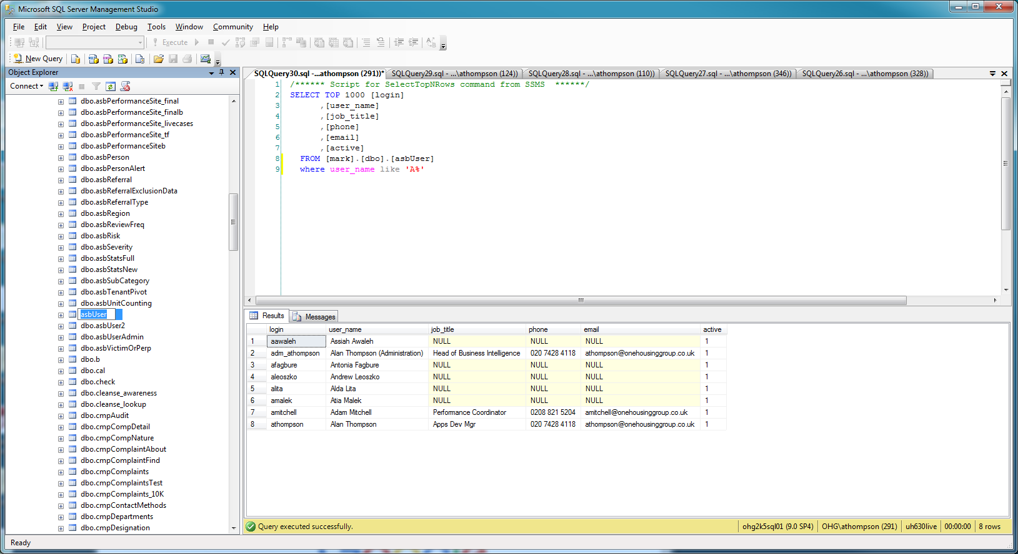

7.2) then if they DO NOT, you can add them. The username which is in the ‘login’ field is a PK or at least must be unique, so duplicates are not allowed hence the self service failure reasons. If they can be added, right click the asbUser table as shown here, to edit the table.

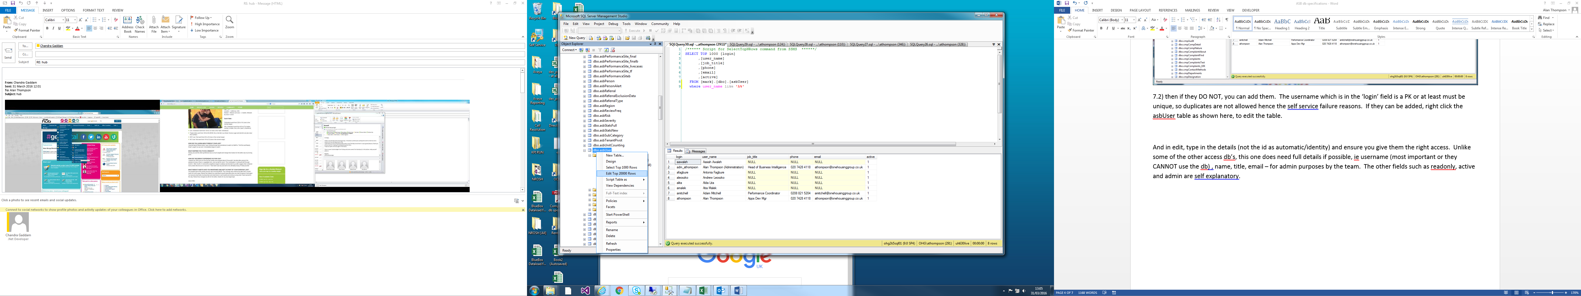

Then whilst in edit, type in the details (There is no id automatic/identity) and ensure you make ‘active’ to be True – or False to deactivate someone later. Unlike the complaints access db, this one does NOT need full details if possible add them, but it is not mandatory, ensure no matter what that login is added (most important or they CANNOT use the db via the SSO) , name, title, email – for admin purposes by the team. The other fields such as readonly, active and admin are self explanatory.

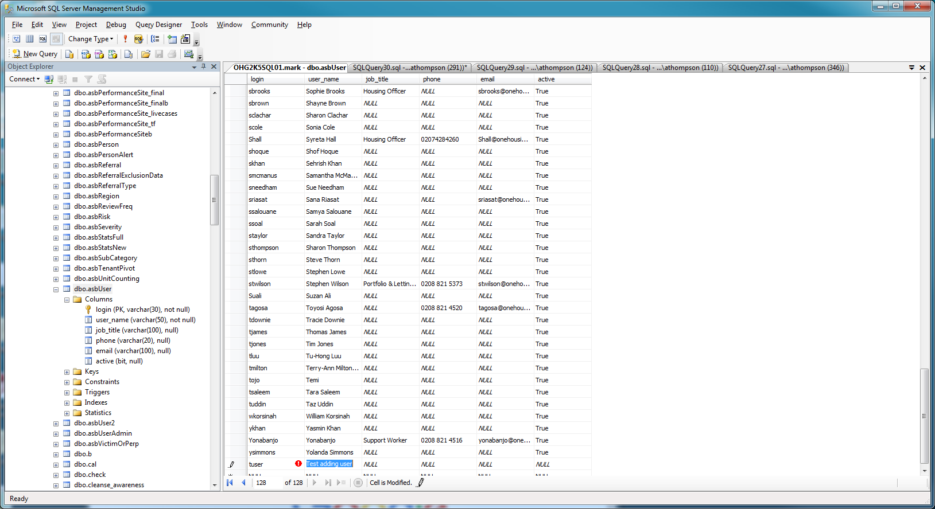

1. Hub links

